### IMG_256

**10 Academy: Artificial Intelligence Mastery**

Week 0 Challenge Document Report

### **Title:** Solar Energy Potential Analysis

Name : Begizew Zerihun

Submission date :8 / 24 / 2024 G.C

### ****Title:**** Solar Energy Potential Analysis

**Executive Summary**

This report evaluates the solar energy potential of three regions based on key solar irradiance metrics and temperature data. The analysis aims to identify the most suitable location for solar energy investments by comparing the Global Horizontal Irradiance (GHI), Direct Normal Irradiance (DNI), Diffuse Horizontal Irradiance (DHI), and temperature (Tamb) across the regions. Based on the findings, Region 1 is recommended due to its superior solar irradiance metrics and favorable temperature conditions, which are optimal for maximizing solar energy generation

**Introduction**

The purpose of this report is to analyze and compare the solar energy potential of three regions to assist in making an informed investment decision. Solar energy potential is primarily assessed through solar irradiance measurements (GHI, DNI, DHI) and temperature data (Tamb). These factors are crucial in determining the efficiency and productivity of solar energy systems.

**Methodology of Data Processing:**

Summary statistics (mean, median, standard deviation, minimum, and maximum) were calculated for each metric to provide a comprehensive overview of the solar energy potential across the regions.

The data processing involved an intensive data cleaning method to ensure accuracy and reliability. This included:

**Data Cleaning:** Comprehensive cleaning was performed to address missing values, outliers, and inconsistencies in the dataset. Each data point was carefully examined and cleaned to maintain the integrity of the statistical analysis.

**Data Validation:** Rigorous checks were implemented to validate the cleaned data, ensuring that it accurately represented the solar irradiance metrics and temperature data across all regions.

**Statistical Analysis:** After cleaning, summary statistics were calculated to provide insights into the central tendencies and variations in solar irradiance and temperature. This involved computing the mean, median, standard deviation, minimum, and maximum values for each metric.

**Visualization:** Bar charts and line graphs were generated to visually compare these metrics across regions. These visualizations were instrumental in contrasting the solar energy potential and identifying the most favorable region for investment.

**Data Analysis and Findings**

**Solar Irradiance Metrics:**

**For our analysis assume**

**benin-malanville ……..**Region 1`

sierraleone-bumbuna…..Region2

togo-dapaong\_qc……..Region3

**Diffuse Horizontal Irradiance (DHI):**

| Metric | Region 1 | Region 2 | Region 3 |
| --- | --- | --- | --- |
| **Mean GHI** | 238.57 | 135.39 | 205.48 |
| **Mean DNI** | 164.87 | 66.17 | 131.88 |
| **Mean DHI** | 115.78 | 94.00 | 106.19 |
| **Mean Tamb** | 28.18 | 25.73 | 27.64 |
| **Max GHI** | 1268.00 | 1015.00 | 1169.00 |
| **Max DNI** | 952.30 | 891.00 | 989.80 |
| **Max DHI** | 759.20 | 738.80 | 805.70 |
| **Std GHI** | 327.96 | 211.92 | 305.01 |
| **Std DNI** | 259.58 | 152.75 | 234.11 |
| **Std DHI** | 156.81 | 143.42 | 151.31 |
| **Std Tamb** | 5.94 | 4.15 | 4.80 |

### 

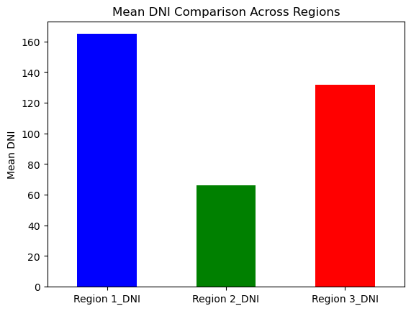

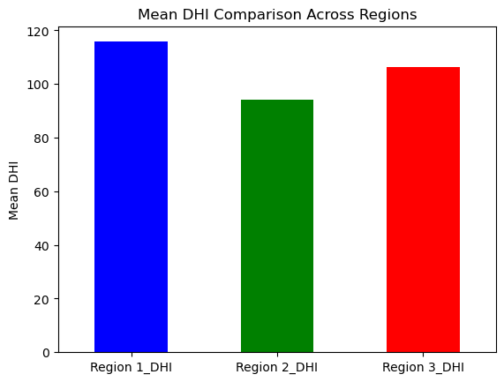

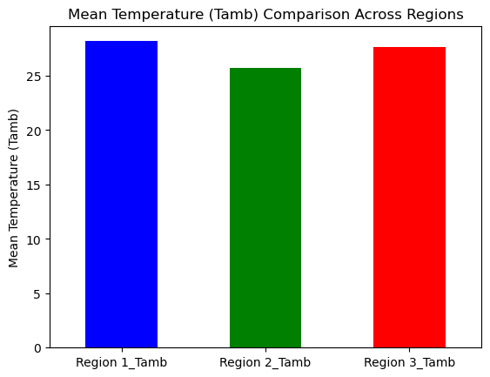

### Evaluate the Key Metrics

**Mean GHI**: Region 1 has the highest mean GHI, which suggests it has the most consistent solar energy available throughout the year.

**Mean DNI**: Region 1 also has the highest mean DNI, which is beneficial for systems that require direct sunlight.

**Mean DHI**: Region 1 has the highest DHI, indicating a good amount of diffuse sunlight, which is favorable for standard photovoltaic systems.

**Mean Temperature (Tamb)**: All regions have a similar average temperature range, but Region 1 is slightly warmer. This might slightly reduce the efficiency of solar panels compared to Regions 2 and 3, but the difference is minor.

**Variability (Std)**: Region 2 has the lowest standard deviations for GHI, DNI, and DHI, indicating more stable and predictable solar conditions compared to Regions 1 and 3. However, Region 1 still offers the highest mean values for these metrics.

**Discussion:**

Based on the analysis, Region 1 stands out as the most favorable location for solar energy investments due to its higher levels of GHI, DNI, and DHI. These metrics suggest that Region 1 has the greatest potential for converting solar radiation into usable energy. Despite its slightly higher average temperature, which might reduce solar panel efficiency marginally, the overall solar irradiance metrics make Region 1 the optimal choice for solar energy projects.

**Region 2,** while having lower solar irradiance metrics, is less favorable compared to Region 1 due to its reduced GHI, DNI, and DHI. Region 2’s lower irradiance levels mean less solar energy potential.

**Region 3** offers a balance between solar irradiance and temperature but does not surpass Region 1 in any key metric.

### Conclusion and Recommendation

Based on the above analysis:

**Region 1** has the highest average values for GHI, DNI, and DHI, making it the most attractive region for maximizing solar energy capture and potential energy production. However, it also has the highest variability, which might indicate some instability in solar conditions. The ambient temperature is slightly higher but not drastically so.

**Region 2** has the lowest averages for GHI, DNI, and DHI, suggesting it would produce less solar energy overall. However, it has the least variability, making it more predictable and stable.

**Region 3** offers a middle ground between Regions 1 and 2. It has higher mean values than Region 2 but lower than Region 1, and its variability is lower than Region 1 but higher than Region 2.

**Recommendation**: **Region 1** appears to be the best option for the organization to invest in due to its higher solar irradiance values (GHI, DNI, and DHI), which indicate a better potential for solar energy production. The slightly higher temperature can be managed with appropriate panel selection and installation strategies. If stability and predictability are more crucial than potential yield, then **Region 2** could be considered as a secondary option due to its lower variability in solar irradiance.

**END!!!**